**CURRENT METHODOLOGY**

The current health inspection scoring methodology works as follows. Establishments all start with a score of 100, and are docked from that 100 score for each violation. For example, a restaurant with violations totaling 10 would have a total score of 90 (100 – 10 = 90). There are three levels of violations, each docking a different amount of points:

|  |  |
| --- | --- |
| **Violation Level** | **Penalty** |
| Foodborne Critical Violation | 10 point deduction |
| Critical Violation | 7 point deduction |
| Non-Critical Violation | 2 point deduction |

Foodborne critical violations and critical violations are the most likely to contribute to food contamination, illness, or environmental health hazard. These kinds of violations include things like the mishandling of food during storage or preparation and cleanliness/hygiene concerns. These are the most serious violations and pose the most immediate risk to the public health. Establishments are then given a letter grade based upon their final score. The grading rubric is as follows:

|  |  |
| --- | --- |
| **Score** | **Grade** |
| 94 – 100 | A |
| 81 - 91 | B |
| Below 80 | C |

**ANALYSIS**

The grades dataset suggests that the only way to pass health inspection is by getting an A, or a score of 94. Only one establishment scored a B who also passed their health inspection. The histogram confirms as much.

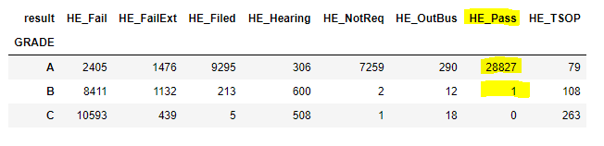

|  |  |
| --- | --- |
| **A** |  |
| **B** |  |
| **C** |  |

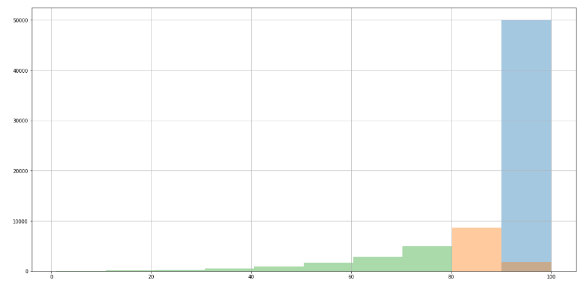

However the violations dataset tells a different story. 28,090 Foodborne Critical Violations, the most serious kind, still led to a passing result for the initial inspection of the establishment. How are these establishments still passing their initial health inspections even though they were docked for the most serious health code violations, and in theory, disqualifying themselves from a passing grade?

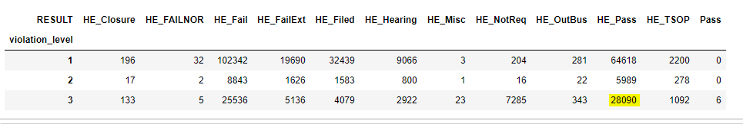

It is my conclusion that there are establishments who are passing initial inspection who have critical level violations, which according to the methodology should disqualify them from a passing grade. These violations are also the most severe, pose the greatest immediate risk to public health, and should be dealt with most urgently.

**RECCOMENDATION**

It is my recommendation that the health inspection grading methodology be moved to a pass/fail system. A letter grade of ‘A’ is in theory the only score that will allow you to pass your inspection, however there are still establishments with critical level violations being issued passing grades. The pass/fail threshold would be the same as receiving an A grade, or a score of 94 or above. This immediately disqualifies any establishment that has even one critical level violation from passing. Even one critical violation can pose an immediate risk to public health. Establishments who have critical violations will automatically be referred for re-inspection, and will be granted a passing grade should they correct the violation upon reinspection.